Class: 3A
Period 25 Unit 4: Our bodies
Lesson 2 (Activity 1- 3)
A. OBJECTIVES:
By the end of the lesson, Ss will be able to:
1. Knowledge:
- use Open your ………! and Touch your …........! to give instructions
- listen to and demonstrate understanding of simple communicative contexts in relation to the topic “Our bodies”.
- Vocabulary: touch, open, mouth, hair
- Skills: speaking and listening
2. Competences:
- Oral Communication: speak about names, ask and answer the questions
- Co-operation: ready to help friends in pair work/ group work.
- Sociability: Talk to each other, say good words to others.
3. Attitude/ Qualities:
- Kindness: Help partners to complete learning tasks.
- Honesty: tell the truth about feelings and emotions
- Diligence: complete learning tasks
B. TEACHING AIDS:
- Teacher: Teacher’s guide Pages 55, 56, audio Tracks 39,40, website sachmem.vn, posters, laptop, pictures, textbook, lesson plan, TV or projector.
- Students: Pupil’s book Page 30, notebooks, workbooks, school things.
C. PROCEDURES:
Teacher’s activities | Students’ activities
1.Warm- up: (3’)  Game: Review  *Aims: to create a friendly and active atmosphere in the class to beginning the lesson.  *Procedure:  - T says to Ss answer the parts of the body  +We use ... for listening (pretend to listen to music)  + We use ... for looking (pretend to wear glasses)  + We use ... for smelling (pretend to smell something good)  + We put makeup on a ... (pretend to put on makeup)  + We hold something with ... (pretend to hold heavy thing)  - Say “Open your book page 30” and look at “Unit 4, Lesson 2 (1,2,3)”.  2. Presentation (16’)  Activity 1. Vocabulary.  *Aims: Ss will be able to know the vocabulary in front of starting the new lesson.  *Procedure:  -T elicits the new words  + touch : chạm (situation)  + open : mở / há (realia)  +mouth :miệng (realia)  + hair : tóc (realia)  - T models (3 times).  - T writes the words on the board.  - Checking: Rub out and remember  Activity 2. Listen, point and repeat:  *Aims: Ss will be able to understand and correctly repeat the sentences in two communicative contexts (pictures) focusing on giving instructions.  *Procedure:  - Have pupils look at Pictures a and b and identify the characters in the pictures.  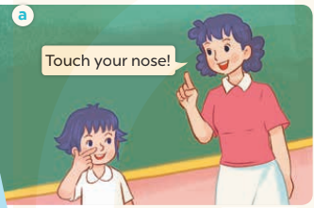  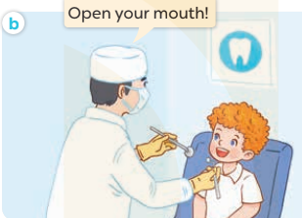  - Play the audio twice (sentence by sentence). Correct their pronunciation where necessary.  - Have Ss to practice the dialogue  - T invites a few pairs to the front of the class to practice.  - T checks pronunciation for ss.  Activity 3 Listen, point and say.  *Aims: Ss will be able to correctly say the words and use Touch your ……..! and Open your ……….! to give instructions.  *Procedure:  * Model sentences:  - T asks Ss look at picture a, b and helps Ss know the structure from the dialogue.  - T introduces new structure for Ss.  - T explains, models and gives meaning.  -Have Ss repeat the model sentences.  - Touch your nose!  - Open your mouth!  3.Practice: (7’)  *Drill pictures  - Elicit and check comprehension the actions and the body parts.  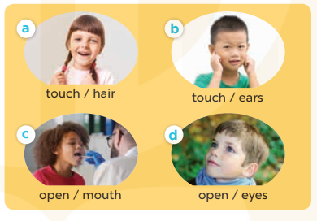  - Run through all the pictures.  - Run through model sentences.  - Have Ss to practise:  + T says the first picture  + Ss say the second picture  + Group A say the third picture  + Group B say the last picture.  - Ask Ss to work in pairs to point and say the strucure Touch your….! Open your…….!  - T controls and corrects.  - Invite a few pairs to point at the pictures and giving the instructions in front of the class.  - Encourage Ss to practise speaking English.  - T gives feedbacks.  4.Production: (7’)  Activity 4. Let’s talk.  *Aims: Ss will be able to enhance the correct use of Touch your …..! and Open your …..! to give instructions  *Procedure:  - Have Ss look at the picture and answer the questions:  +Who are they?  + What are they doing?  - T asks Ss look at the first speech bubble and say Touch your……!  - Get Ss to repeat and give instructions several times in pairs.  - T models: Go around the classroom, pointing to the parts of body and says Touch your…..!  - Ask Ss work in pairs to give more instructions using the words that they have learnt (ex: nose, face, ear, …..).  - Invite some pairs to perform in front of the class.  - Give feedbacks  *Consolidation  *Aims: Ss will be able consolidate and wrap up the content of the lesson.  *Procedure:  - T asks ss to answer the following questions:  + What have you learnt from the lesson today?  +What are the core values of the lesson? (if the teacher can take from the lesson).  - T review the vocabulary and model sentences.  - T praises some Ss who are hardworking / active/ good…. as well as encourage others to try more.  5. Homework. (2’)  - Learn the vocabulary and model sentences by heart  - Prepare the new lesson: Unit 4, Lesson 2 (4,5,6). | -Ss answer  + an ear  + an eye  + a nose  + a face  + a hand  - Ss open their books  -Ss listen and answer  - - Ss listen and repeat  + Choral repetition (3 times).  + Individual repetition (3 ss)  - Ss take note  - Ss look, remember and write  -Look at the pictures and get to know the characters in the pictures.  + In picture a: Ms Hoa says: Touch your nose!  + In pucture b: The doctor says: Open your mouth!  -Ss listen and repeat in chorus (twice)  -Ss work in pairs to practice  -Ss practice the dialogue  -Ss listen  -Ss look at the picture and answer.  -Ss listen  -Ss listen and repeat  -Ss repeat to the actions and the body parts.  -Ss look at the picture and answer  + In picture a: a girl touching her hair  + In picture b: a boy touching his ears  + In picture c: a boy opening his mouth  + In picture d: a boy opening his eyes  - Ss look, listen and repeat  -Ss practice in chorus  -Ss work in pairs to practice  -Ss point and say  -Ss listen.  -Ss listen  -Ss look at the picture and listen  + A boy asks a girl to touch her hair  +A doctor asks a boy to open his mouth.  -Ss look and answer  + hair  -Ss say  - Ss answer  -Ss work in pairs  -Ss perform in front of the class.  -Ss answer the questions  - Ss listen  -Ss listen and clap their hands  -Ss listen and take note

